Six knowledge points:
1 Please describe the relationship between Design and implementation?
- Design decide upon the look and functioning of an object, typically by making a detailed drawing of it.
- Implementation refers to the process of putting a decision or plan into effect and execution.

2. What are Common activities in the software design processes?
Architectural design. The sub-systems of system and their relationships are identified based on the main functional requirements of software.
- Abstract specification.
- Interface design.
- Component design.
- Data structure design.
- Algorithm design.

3. Please describe differences between system Context and interaction models.
- A system context is a structural model for example a class diagram that demonstrates the other systems in the environment of the system being developed.
- An interaction model is a dynamic model for example a use case diagram + structured natural language description that shows how the system interacts with its environment as it is used.

4. What we should do before Architectural design?
Pre-Design is a a general term for what we do before we start architectural design. This will include preliminary research on the property owner's part and the architect. We often do a zoning analysis in pre-design to determine is required. System analysis is a part of pre-design.

5. Please describe Approaches to identify the principal system objects?
- Use a grammatical approach based on a natural language description of the system used in HOOD method.
- Base the identification on tangible things in the application domain. ▪
- Identify objects based on what participates in what behaviour.
- ▪ Identify objects, attributes and methods in each scenario.

6. Please give some descriptions for the Weather station state diagram.
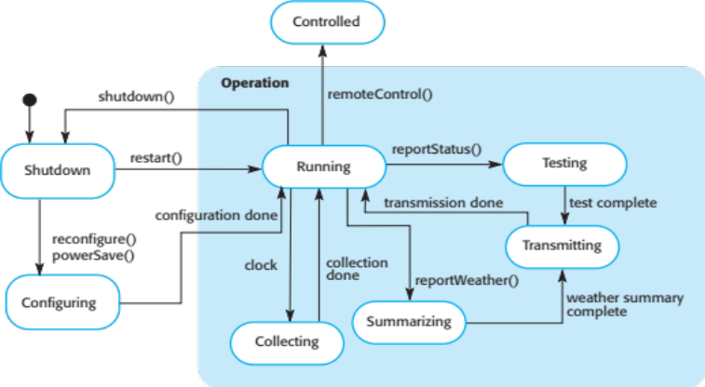
- These model the behaviour of the system in response to external and internal events.
- They show the system’s responses to stimuli so are often used for modelling real-time / embeded systems.
- State machine models show system states as nodes and events as arcs between these nodes. - When an event occurs, the system moves from one state to another.

